Please read the instructions, descriptions and questions below carefully and follow these steps:
- Access the tool (https://tool.thermos-project.eu)
- Watch Exercise 1 clip we prepared for using the software
- Complete the tasks step-by-step as outlined below
Please make sure to fill in the answers in the dedicated “my answer” fields for each task.
Once all “my answer” fields have been filled in, please check whether all your personal details (name, email and date of completion) are clearly stated and correct.
Once all information is in place, please save your document in PDF format adding your name to the title, thus: THERMOS Pathway D Exercise 1 – Your Name Surname” and send it to info@thermos-project.eu and submit until 1 Dec 2020*.
*Please note that submitting all three exercises before 1 Dec is required to receive a certificate.

Trainer – Personal details (please complete before starting the exercise)
Name & Surname: ………........ ………………….
Email: ………………………………….
Date of completion: ………………………………….

Task 1 - Map creation – Bradford on Avon (UK)
Create an account, a project and a map.
- The created map should be for the example area you can see on the picture below in Bradford (UK) on the Avon River;
- Use 2000 heating degree days for the heat demand estimate.
- Find “St Thomas More Catholic Church” on your map, one street north of the northernmost bend in the river, slightly west of the bridge.
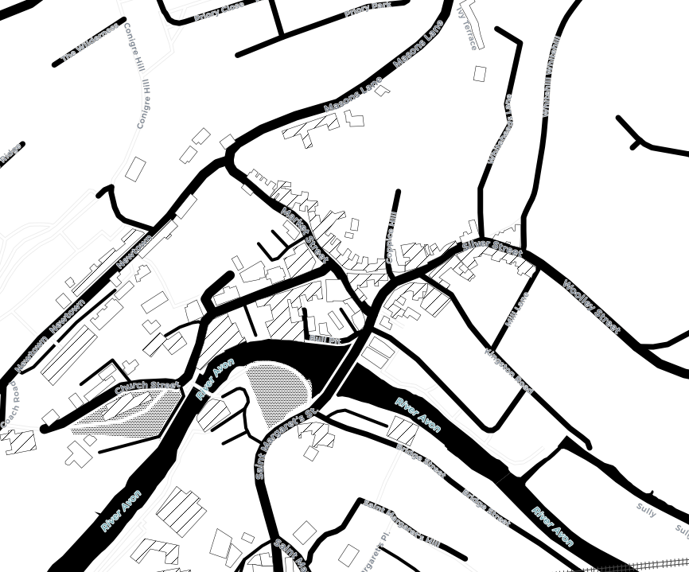

Question 1:
What is the modelled annual heat demand for this building?
My answer:

- Public spaces – annual demand & peak demands
In the area shown, there are five churches/ religious places of worship
- Select them all and identify their total annual demand and their total peak demand
- In the area shown, there are 4 pubs, write down their names and identify the annual & peak demands per pub.

Question 2:
What is the total annual demand of the five churches?
My answer:

What is the total peak demand of the churches (combined)?
My answer:

List the four pubs with their individual annual demand and their peak demand?
My answer:

- Network construction
Construct a network problem containing the four pubs as required demands (red), and St Thomas More Catholic Church.
- Mark St Thomas More as a supply location with the following parameters:
- Maximum capacity: 10MW
- Supply cost:3c/kWh (assume units are €cents)
- Capacity cost: 300¤/kW (assume units are €)
- CO2 factor: 300 g/kWh
- Allow the model to use any of the roads on the map for pipes.
- Ask the model to solve your network, and look at the solution summary.

Question 3:
What total length of pipe is required?
My answer:
How much revenue does the church receive from pubs?
My answer:
What are the annual associated emissions?
My answer:

- Cooling network
Go back to the project page and click on ‘COLD NET +’ and create a cooling network.

Question 4:
What different user-input data would be needed if optimising a cooling network?
My answer:

