Please read the instructions, descriptions and questions below carefully and follow these steps:
- Access the tool (https://tool.thermos-project.eu)
- Watch Exercise 2 clip we prepared for using the software
- Complete the tasks step-by-step as outlined below
Please make sure to fill in the answers in the dedicated “my answer” fields for each task.
Once all “my answer” fields have been filled in, please check whether all your personal details (name, email and date of completion) are clearly stated and correct.
Once all information is in place, please save your document in PDF format adding your name to the title, thus: THERMOS Pathway D Exercise 2 – Your Name Surname” and send it to info@thermos-project.eu and submit until 1 Dec 2020*.
*Please note that submitting all three exercises before 1 Dec is required to receive a certificate.

Trainer – Personal details (please complete before starting the exercise)
Name & Surname: ………........ ………………….
Email: ………………………………….
Date of completion: ………………………………….

Optimisation decisions - Introduction
This exercise does not necessarily involve using the model per se – it is intended to increase your understanding of the interaction between constraints and objectives as described in the accompanying video.
There are three parts to consider:
- Choosing between two supply locations
- Ways for things to be infeasible
- Drivers for things to happen
Part 1: Choosing between two supply locations
Question 1:
How would you set up the model to pick between two different supply locations for a network whose constituent demands you had already chosen?
My answer:

Part 2: Ways for things to be infeasible
Question 2:
Look at the three scenarios A, B and C below. Considering each in turn, describe ways in which these problems could be ‘infeasible’ (i.e. have no permitted solution).

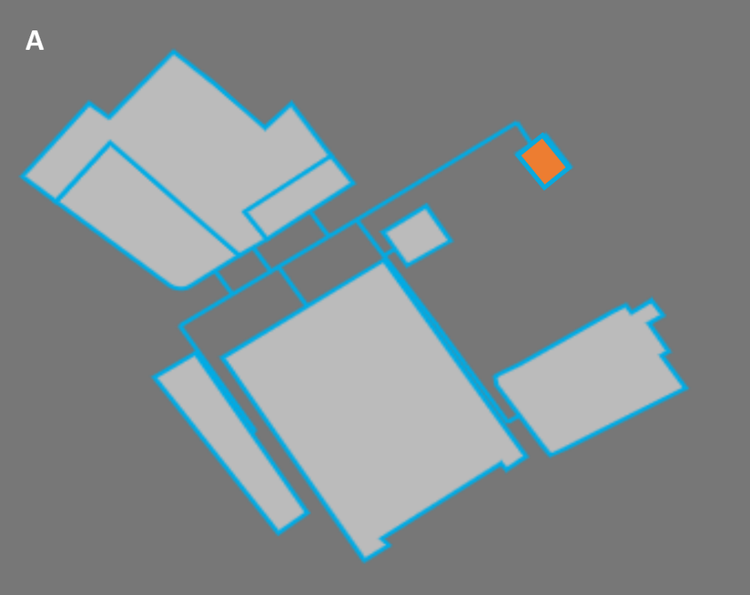
My answer:

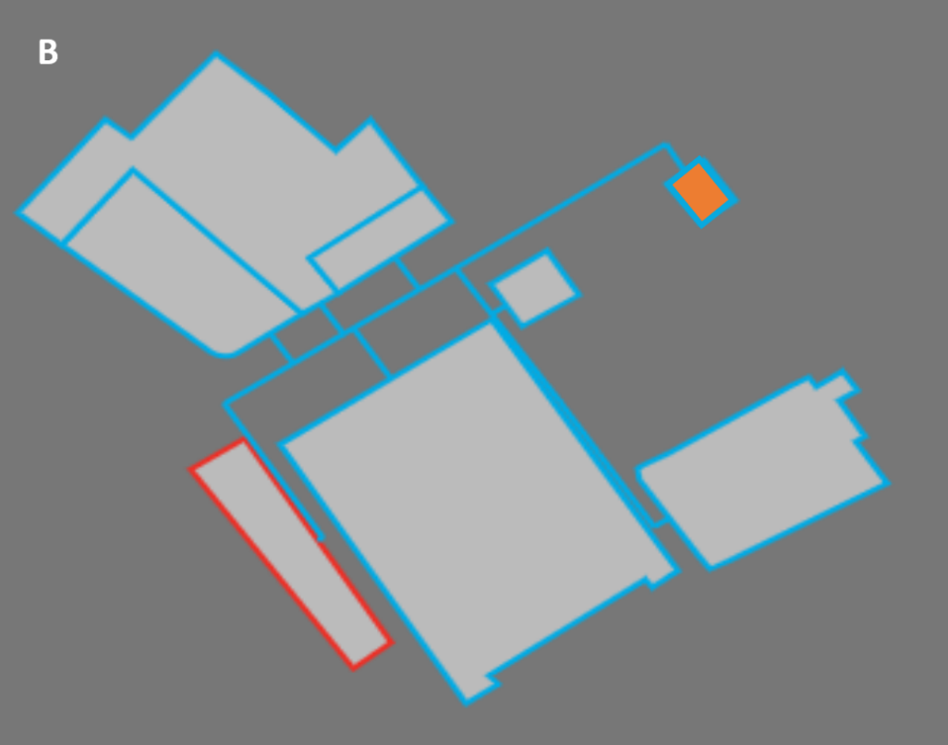
My answer:

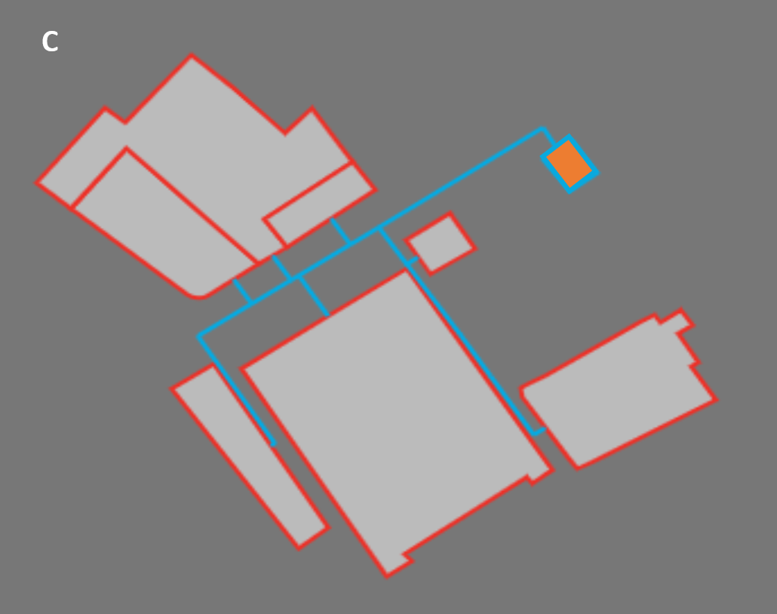
My answer:

Part 3: Drivers for things to happen
Question 3:
When the objective is set to ‘Maximise Network NPV’ you can still tell the model to offer insulation measures and other heating systems.
These systems produce no revenue to the network. Can you describe circumstances in which the model might decide to insulate a building or purchase a new individual heating system when in this configuration?
My answer:

